Terraform challenge-2
1.Create VPC
2.Create Internet gateway
3.Create Custom Route Table
4.Create Subnet
5.Associate subnet with Route Table
6.Create Security Group to allow port 22.80,443
7.Create a network interface with an ip in the subnet that was created in step 4
8.Assign an elastic IP to the network interface created in step 7
9.Create Ubuntu server and install/enable apache2
Objective:
Provision a complete AWS public-network infrastructure using Terraform, including a custom VPC, subnet, Internet Gateway, route table, security group, network interface, Elastic IP, and an Ubuntu EC2 server running Apache2.

Architecture
Internet
|
|
Elastic IP (EIP)
|
Network Interface
Private IP
|
Ubuntu EC2 Server
Apache2 :80
|
Public Subnet
10.0.1.0/24
|
Custom Route Table
0.0.0.0/0 -> IGW
|
Internet Gateway
|
VPC 10.0.0.0/16

Terraform Code
Create a directory:
mkdir terraform-vpc-apache
cd terraform-vpc-apache
Create main.tf:
terraform {
required_providers {
aws = {
source = "hashicorp/aws"
}
}
}

provider "aws" {
region = "us-east-1"
}

# ---------------------------------------------------------
# 1. Create VPC
# ---------------------------------------------------------

resource "aws_vpc" "main" {
cidr_block = "10.0.0.0/16"

tags = {
Name = "terraform-vpc"
}
}

# ---------------------------------------------------------
# 2. Create Internet Gateway
# ---------------------------------------------------------

resource "aws_internet_gateway" "igw" {
vpc_id = aws_vpc.main.id

tags = {
Name = "terraform-igw"
}
}

# ---------------------------------------------------------
# 3. Create Custom Route Table
# ---------------------------------------------------------

resource "aws_route_table" "public" {
vpc_id = aws_vpc.main.id

route {
cidr_block = "0.0.0.0/0"
gateway_id = aws_internet_gateway.igw.id
}

tags = {
Name = "terraform-public-route-table"
}
}

# ---------------------------------------------------------
# 4. Create Subnet
# ---------------------------------------------------------

resource "aws_subnet" "public" {
vpc_id = aws_vpc.main.id
cidr_block = "10.0.1.0/24"
availability_zone = "us-east-1a"
map_public_ip_on_launch = false

tags = {
Name = "terraform-public-subnet"
}
}

# ---------------------------------------------------------
# 5. Associate Subnet with Route Table
# ---------------------------------------------------------

resource "aws_route_table_association" "public" {
subnet_id = aws_subnet.public.id
route_table_id = aws_route_table.public.id
}

# ---------------------------------------------------------
# 6. Create Security Group
# Allow SSH 22, HTTP 80, HTTPS 443
# ---------------------------------------------------------

resource "aws_security_group" "web_sg" {
name = "terraform-web-sg"
description = "Allow SSH HTTP and HTTPS"
vpc_id = aws_vpc.main.id

ingress {
description = "SSH"
from_port = 22
to_port = 22
protocol = "tcp"
cidr_blocks = ["0.0.0.0/0"]
}

ingress {
description = "HTTP"
from_port = 80
to_port = 80
protocol = "tcp"
cidr_blocks = ["0.0.0.0/0"]
}

ingress {
description = "HTTPS"
from_port = 443
to_port = 443
protocol = "tcp"
cidr_blocks = ["0.0.0.0/0"]
}

egress {
from_port = 0
to_port = 0
protocol = "-1"
cidr_blocks = ["0.0.0.0/0"]
}

tags = {
Name = "terraform-web-sg"
}
}

# ---------------------------------------------------------
# 7. Create Network Interface
# ---------------------------------------------------------

resource "aws_network_interface" "web_eni" {
subnet_id = aws_subnet.public.id
private_ips = ["10.0.1.10"]
security_groups = [aws_security_group.web_sg.id]

tags = {
Name = "terraform-web-eni"
}
}

# ---------------------------------------------------------
# 8. Assign Elastic IP to Network Interface
# ---------------------------------------------------------

resource "aws_eip" "web_eip" {
domain = "vpc"

network_interface = aws_network_interface.web_eni.id
associate_with_private_ip = "10.0.1.10"

depends_on = [
aws_internet_gateway.igw
]

tags = {
Name = "terraform-web-eip"
}
}

# ---------------------------------------------------------
# Find latest Ubuntu AMI
# ---------------------------------------------------------

data "aws_ami" "ubuntu" {
most_recent = true

owners = ["099720109477"]

filter {
name = "name"
values = ["ubuntu/images/hvm-ssd-gp3/ubuntu-noble-24.04-amd64-server-*"]
}

filter {
name = "virtualization-type"
values = ["hvm"]
}

filter {
name = "root-device-type"
values = ["ebs"]
}
}

# ---------------------------------------------------------
# 9. Create Ubuntu Server and Install Apache2
# ---------------------------------------------------------

resource "aws_instance" "web_server" {
ami = data.aws_ami.ubuntu.id
instance_type = "t3.small"

key_name = "your-key-name"

network_interface {
network_interface_id = aws_network_interface.web_eni.id
device_index = 0
}

user_data = <<-EOF
#!/bin/bash

apt-get update -y

apt-get install -y apache2

systemctl enable apache2

systemctl start apache2

echo "<h1>Apache2 Server Deployed Using Terraform</h1>" > /var/www/html/index.html
EOF

tags = {
Name = "terraform-apache-server"
}

depends_on = [
aws_network_interface.web_eni,
aws_eip.web_eip
]
}

# ---------------------------------------------------------
# Outputs
# ---------------------------------------------------------

output "vpc_id" {
value = aws_vpc.main.id
}

output "subnet_id" {
value = aws_subnet.public.id
}

output "security_group_id" {
value = aws_security_group.web_sg.id
}

output "network_interface_id" {
value = aws_network_interface.web_eni.id
}

output "private_ip" {
value = aws_network_interface.web_eni.private_ip
}

output "elastic_ip" {
value = aws_eip.web_eip.public_ip
}

output "instance_id" {
value = aws_instance.web_server.id
}

output "apache_url" {
value = "http://${aws_eip.web_eip.public_ip}"
}

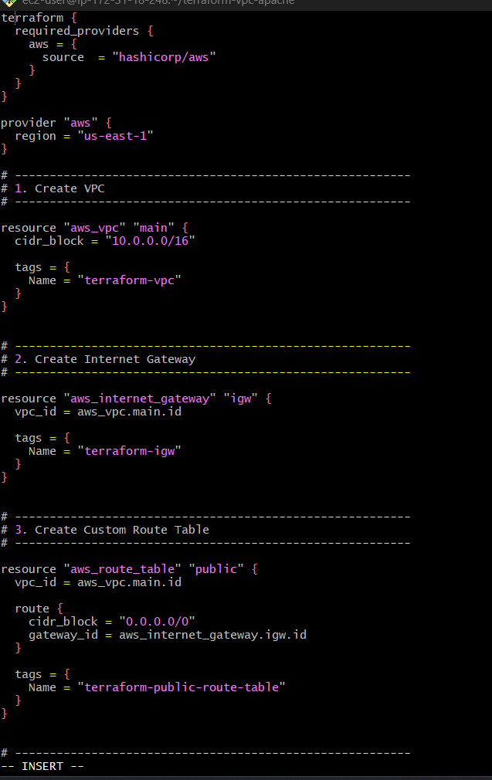

Important: change the key name
In this section:
key_name = "your-key-name"
replace it with your actual AWS EC2 key pair name, for example:
key_name = "challenge"
If your key pair is called docker-server-key, use:
key_name = "docker-server-key"

Implementation

Step 1: Initialize Terraform
terraform init
Expected:
Terraform has been successfully initialized!
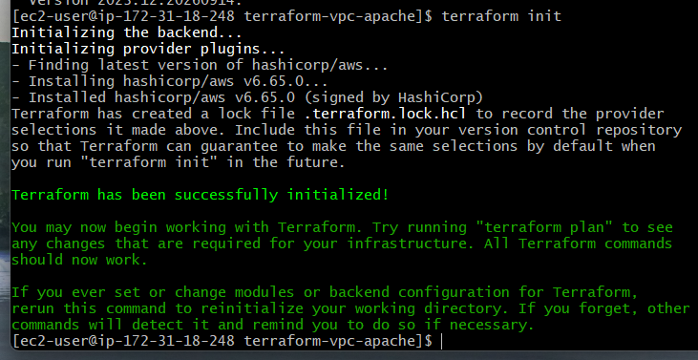

Step 2: Validate
terraform validate
Expected:
Success! The configuration is valid.

Step 3: Review the plan
terraform plan
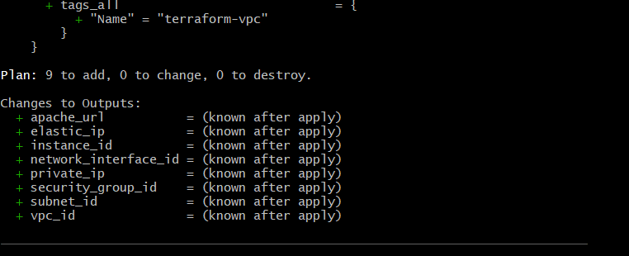
You should see resources planned for creation, including:
aws_vpc.main
aws_internet_gateway.igw
aws_route_table.public
aws_subnet.public
aws_route_table_association.public
aws_security_group.web_sg
aws_network_interface.web_eni
aws_eip.web_eip
aws_instance.web_server

Step 4: Create everything
terraform apply
Enter:
Yes
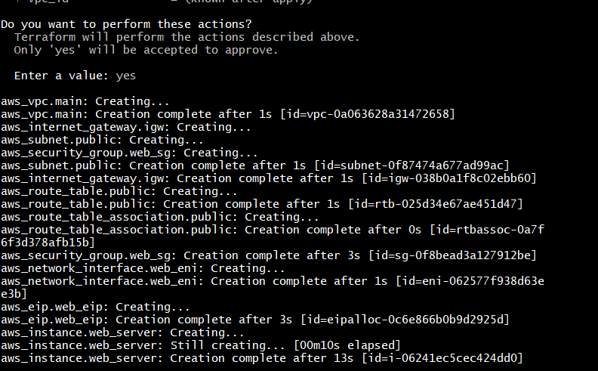

Validation

1. Check Terraform outputs
terraform output
You should get values similar to:
elastic_ip = "54.xx.xx.xx"
instance_id = "i-xxxxxxxxxxxxxxxxx"
network_interface_id = "eni-xxxxxxxxxxxxxxxxx"
private_ip = "10.0.1.10"
subnet_id = "subnet-xxxxxxxx"
vpc_id = "vpc-xxxxxxxx"
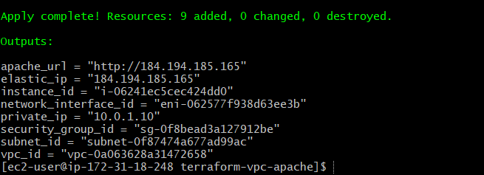

2. Test Apache
Take the Elastic IP from:
terraform output elastic_ip
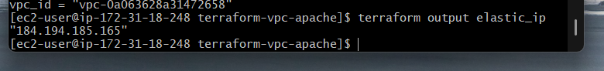
Then open:
http://<ELASTIC-IP>
You should see:
Apache2 Server Deployed Using Terraform
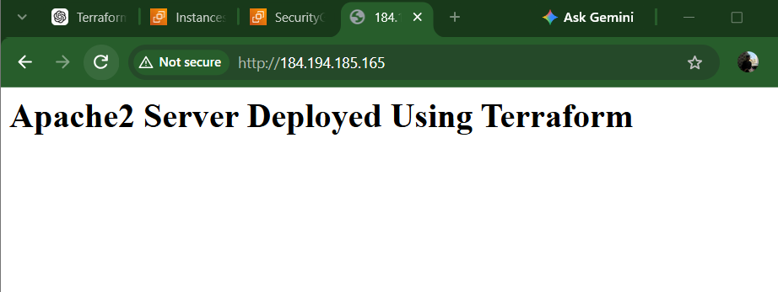

3. SSH into the server
ssh -i your-key.pem ubuntu@<ELASTIC-IP>
For example:
ssh -i challenge.pem ubuntu@54.xx.xx.xx
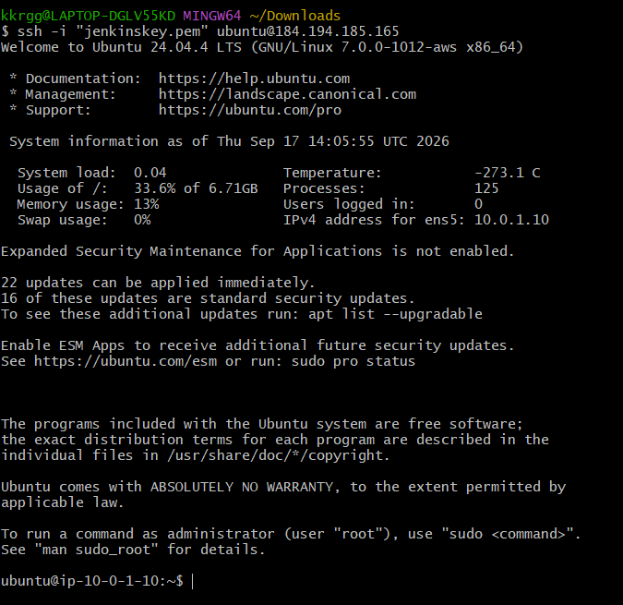

4. Verify Apache

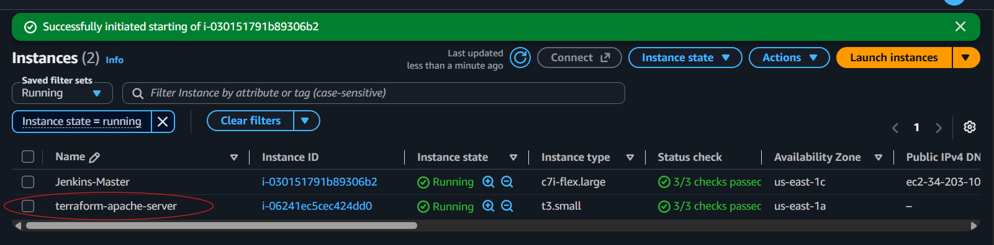
Inside the EC2 instance:
systemctl status apache2
Expected:
Active: active (running)
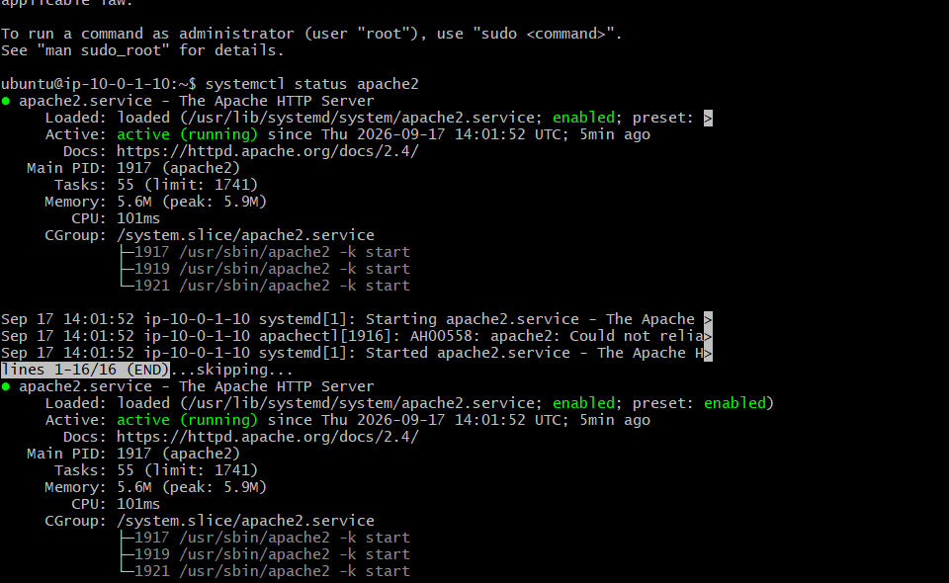
Check whether Apache is enabled:
systemctl is-enabled apache2
Expected:
enabled
Check Apache response:
curl http://localhost
Expected:
<h1>Apache2 Server Deployed Using Terraform</h1>
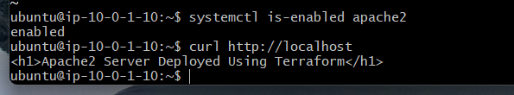

Outcome:
Successfully provisioned an AWS web-server environment completely through Terraform. The Ubuntu EC2 instance is connected to a custom VPC through a public subnet and custom route table, uses a dedicated network interface with a static private IP and Elastic IP, allows SSH/HTTP/HTTPS through a security group, and runs Apache2 automatically through Terraform user_data.

